Homework 3 Exact 3-Bit Adder

Maximilian Burr
Description of the circuit:

To implement the 3-Bit Exact Adder we used the 1-Bit Adder supplied with the lab as base.
We added 4 new memristors for the insertion of a2,b2,a3 and b3. That new memristors are representing the 2 new bits we are calculating in the adder.

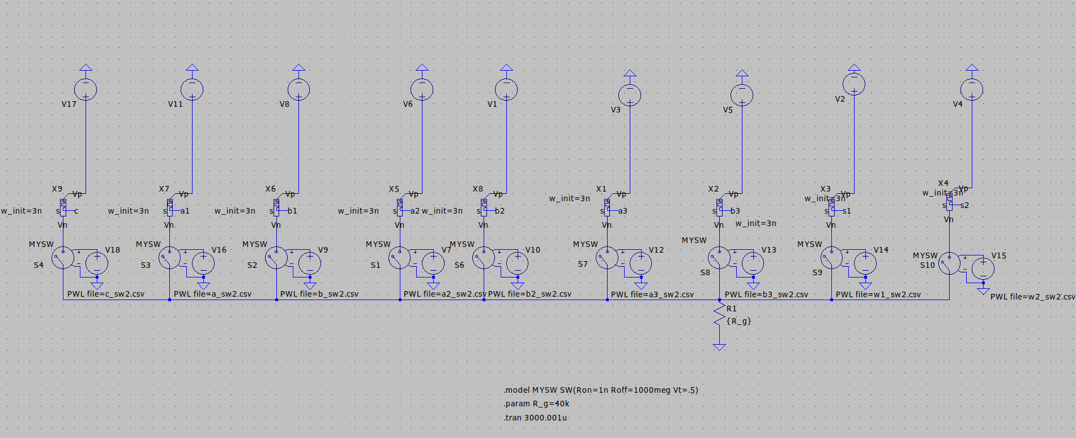
Implementation Details:

Algorithm:

| Step | Operation | Equivalent Logic |
|------|---------------------------------|--------------------------------------------------------|
| 1 | s1 = 0 | FALSE (s1) |
| 2 | s2 = 0 | FALSE (s2) |
| 3 | a → s1 = s1´ | NOT (a) |
| 4 | b → s2 = s2´ | NOT (b) |
| 5 | s1´→ b = b´ | NOT(a) → b |
| 6 | a → s2´= s2´´ | a → NOT(b) |
| 7 | a = 0 | FALSE (a) |
| 8 | b´→ a = a´ | NOT (NOT (a) → b) |
| 9 | s2´´ → a´= a´´ | NOT (XOR (a,b)) |
| 10 | s1 = 0 | FALSE (s1) |
| 11 | c →s1 = s1´ | NOT (c) |
| 12 | s2´´ → c = c´ | (a → NOT(b)) → c |
| 13 | a´´ → s1´ = s1´´ | NOT(XOR(a,b)) → NOT(c) |
| 14 | a = 0 | FALSE (a) |
| 15 | s1´´ → a = a´ | NOT [ NOT(XOR(a,b)) → NOT(c )] |
| 16 | s2 = 0 | FALSE (s2) |
| 17 | c´ → s2 = s2´ | NOT [(a → NOT(b)) → c] |
| 18 | b´ → s2´= s2´´ | (NOT(a) → b) → NOT [(a → NOT(b)) → c] |
| 19 | b´ →c´ = c´´ | (NOT(a) → b) → [(a → NOT(b)) → c] |
| 20 | c´´ → a´ = a´´ | {(NOT(a) → b) → [(a → NOT(b)) → c]}→ {NOT [ NOT(XOR(a,b)) → NOT(c )]} = SUM
| 21 | c = 0 | FALSE(c)
| 22 | s2´´→ c = c´ | NOT{(NOT(a) → b) → NOT [(a → NOT(b)) → c]} = Carry Out

Repeat the steps for a2,b2
| 3 | a2 → s1 = s1´ | NOT (a) |
| 4 | b2 → s2 = s2´ | NOT (b) |
| 5 | s1´→ b2 = b2´ | NOT(a) → b |
| 6 | a2 → s2´= s2´´ | a → NOT(b) |
| 7 | a2 = 0 | FALSE (a) |
| 8 | b2´→ a2 = a2´ | NOT (NOT (a) → b) |
| 9 | s2´´ → a2´= a2´´ | NOT (XOR (a,b)) |
| 10 | s1 = 0 | FALSE (s1) |
| 11 | c →s1 = s1´ | NOT (c) |
| 12 | s2´´ → c = c´ | (a → NOT(b)) → c |
| 13 | a2´´ → s1´ = s1´´ | NOT(XOR(a,b)) → NOT(c) |
| 14 | a2 = 0 | FALSE (a) |
| 15 | s1´´ → a2 = a2´ | NOT [ NOT(XOR(a,b)) → NOT(c )] |
| 16 | s2 = 0 | FALSE (s2) |
| 17 | c´ → s2 = s2´ | NOT [(a → NOT(b)) → c] |
| 18 | b2´ → s2´= s2´´ | (NOT(a) → b) → NOT [(a → NOT(b)) → c] |
| 19 | b2´ →c´ = c´´ | (NOT(a) → b) → [(a → NOT(b)) → c] |
| 20 | c´´ → a2´ = a2´´ | {(NOT(a) → b) → [(a → NOT(b)) → c]}→ {NOT [ NOT(XOR(a,b)) → NOT(c )]} = SUM
| 21 | c = 0 | FALSE(c)
| 22 | s2´´→ c = c´ | NOT{(NOT(a) → b) → NOT [(a → NOT(b)) → c]} = Carry Out
Repeat the steps for a3,b3
| 3 | a3 → s1 = s1´ | NOT (a) |
| 4 | b3 → s2 = s2´ | NOT (b) |
| 5 | s1´→ b3 = b3´ | NOT(a) → b |
| 6 | a3 → s2´= s2´´ | a → NOT(b) |
| 7 | a3 = 0 | FALSE (a) |
| 8 | b3´→ a3 = a3´ | NOT (NOT (a) → b) |
| 9 | s2´´ → a3´= a3´´ | NOT (XOR (a,b)) |
| 10 | s1 = 0 | FALSE (s1) |
| 11 | c →s1 = s1´ | NOT (c) |
| 12 | s2´´ → c = c´ | (a → NOT(b)) → c |
| 13 | a3´´ → s1´ = s1´´ | NOT(XOR(a,b)) → NOT(c) |
| 14 | a3 = 0 | FALSE (a) |
| 15 | s1´´ → a3 = a3´ | NOT [ NOT(XOR(a,b)) → NOT(c )] |
| 16 | s2 = 0 | FALSE (s2) |
| 17 | c´ → s2 = s2´ | NOT [(a → NOT(b)) → c] |
| 18 | b3´ → s2´= s2´´ | (NOT(a) → b) → NOT [(a → NOT(b)) → c] |
| 19 | b3´ →c´ = c´´ | (NOT(a) → b) → [(a → NOT(b)) → c] |
| 20 | c´´ → a3´ = a3´´ | {(NOT(a) → b) → [(a → NOT(b)) → c]}→ {NOT [ NOT(XOR(a,b)) → NOT(c )]} = SUM
| 21 | c = 0 | FALSE(c)
| 22 | s2´´→ c = c´ | NOT{(NOT(a) → b) → NOT [(a → NOT(b)) → c]} = Carry Out

Output of the circuit:

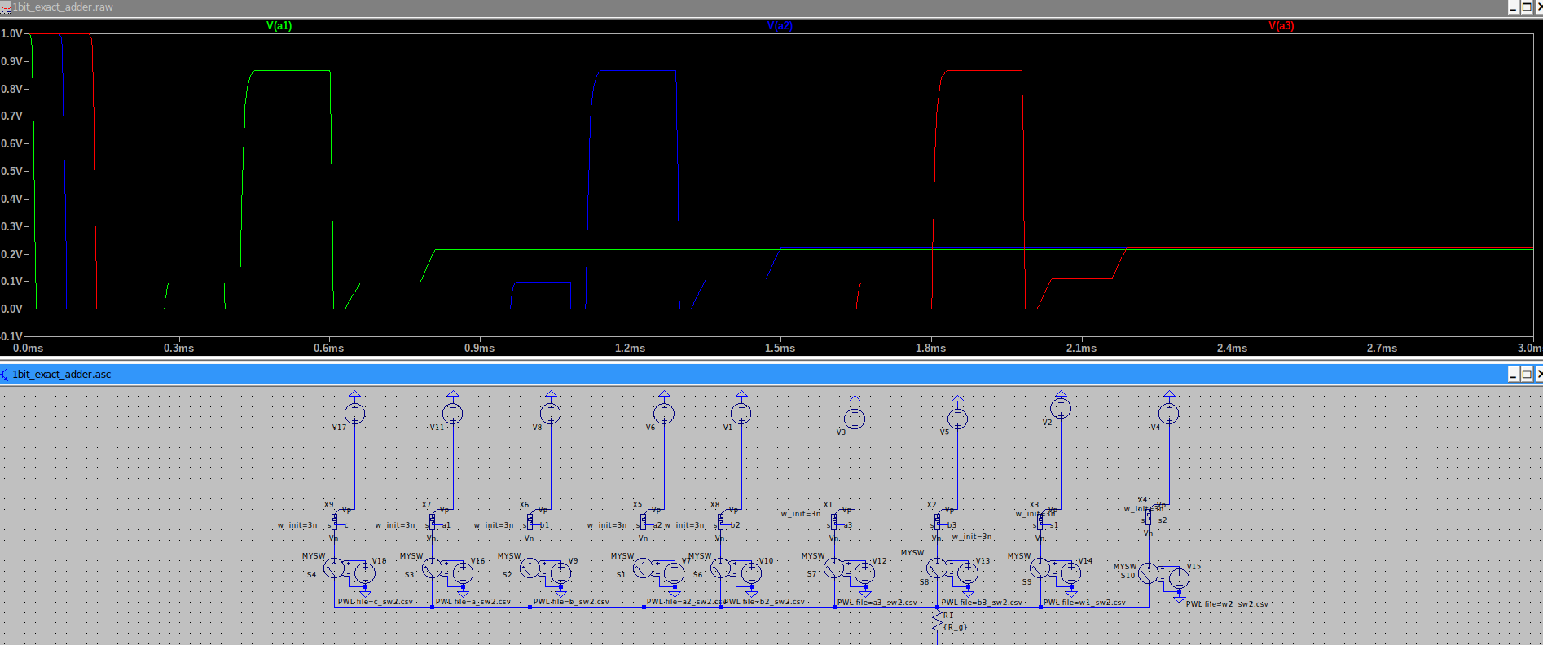
Correctness of the results:

We tried the calculator with different values that we are trying to add and compared the values with the truth table of an exact 3 bit adder.

In this implemented memristor adder the outputs are stored in the input memristors of a1, a2 and a3.

